SAP CAP - ASN0000137

Current Version:
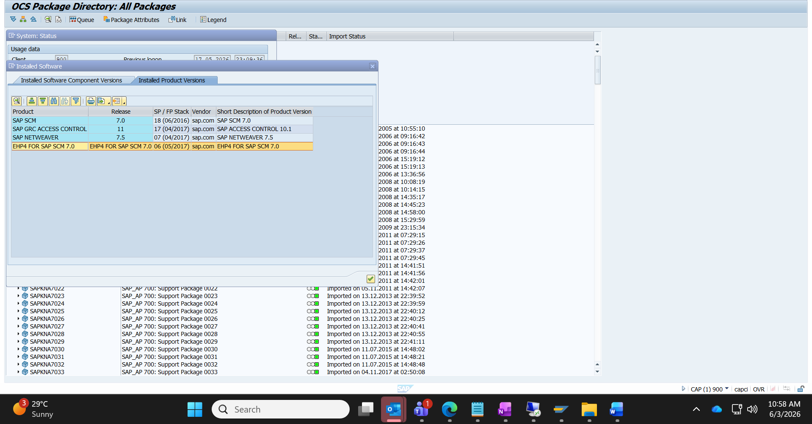
Last updated on:4-Nov-2017
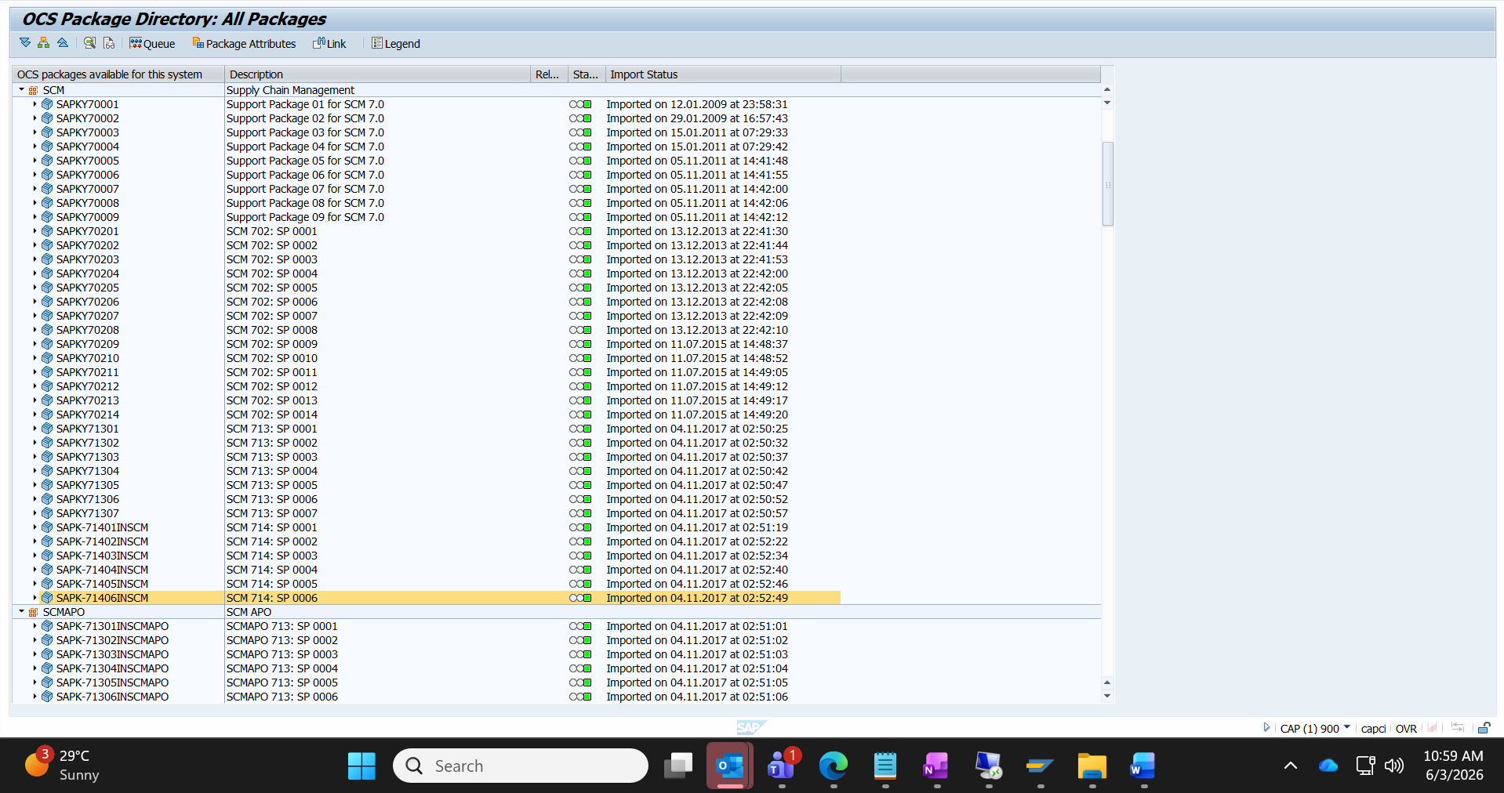

SAP Support End of Mainstream Maintenance: | 31.12.2027

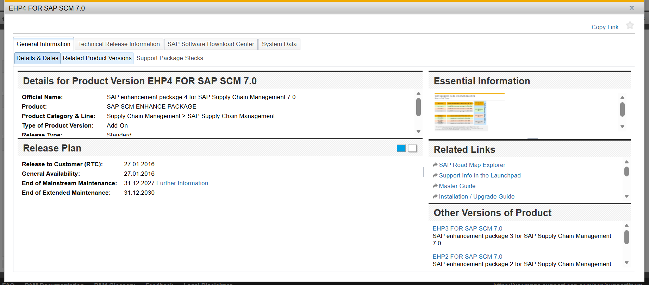

Latest patch available is 25:
